1. **Number-related types**

* Change a variable’s type from **int** to **float** and vice versa.

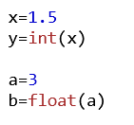

**2. Sequence types**

The following list shall be given:

L= [ -4 25 51 96 -22 5.12 194 4 17 3.4]

* Print the list elements in ascending order;

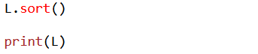

* Print the list elements in descending order;



* Print all the negative integers;

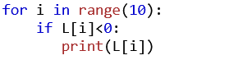

* Print all list items containing decimals;

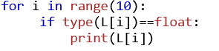

* Print all the elements divisible by a given number ;

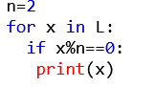

* Print the numbers that are perfect squares;

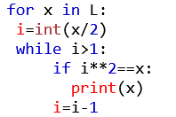

* Print all the prime numbers*;

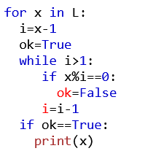

* Print the maximum value of the given numbers (with/without functions);

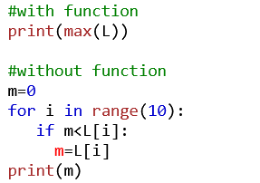

* Print the minimum value of the given numbers (with/without functions).

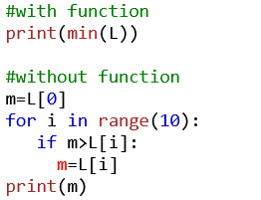

**3. Text values**

Exercises related to words:

The following word shall be given:

**w=”banana”**

- Print the number of letters;



- Print the letters in reverse order;



- Print the word in upper case;



Exercises related to sentences:

The following sentence shall be given:

**s=”My name is John”**

- Print the number of characters;



- Print the number of words;

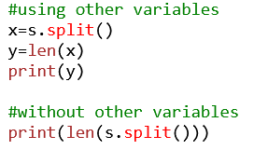

- Print the words in reverse order;

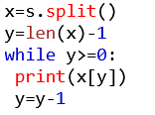

- Replace all spaces with the character “*” .



**4. Control structures**

- Print a given number at a given power with while/for;

**5^4**:

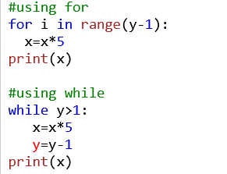

- Print “n” factorial;

**4! :**

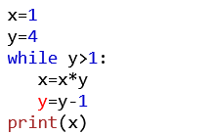

- Print the number of divisors of a given number;

n=24

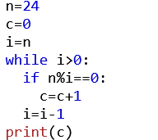

- Check if a given number is prime.

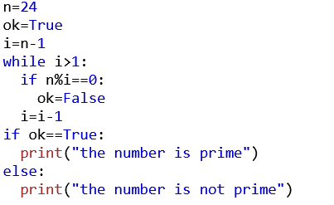

**5. Functions**

- Calculate the sum of the elements of a list/tuple;

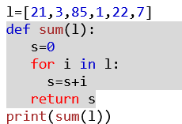

- Calculate the sum of the digits of a number;

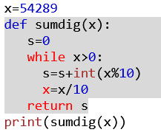

- Calculate the maximum of the digits of a number;

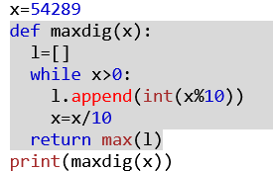

- Calculate the minimum of the digits of a number;

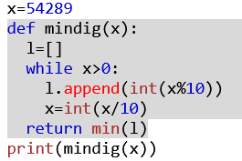

- Check if a given number is prime;

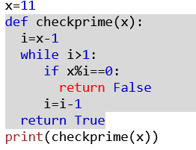

- Check if a given number is a perfect square.

